8 Zone IP Network Audio Adapter

FIP-900DZ

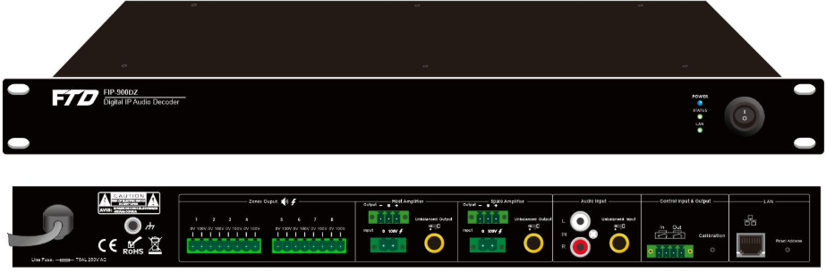

Description:
The IP network 8 zone audio adapter with decoder is the main equipment of the IP network PA system. It is built-in decoder which can decode the network audio signal into analog to feed in analog amplifier. It is also built-in an eight zone speaker selector can split one amplifier into 8 zones to power different loudspeaker zones.
The IP network 8 zone audio adapter with decoder is ideal sound system solution for multiple room sound system, it could be set up over existing network LAN/WAN and internet work, support more than 300 decoders online at the same time. There are eight zone contact outputs to third party for zone status monitoring. It is designed in 1U height of rack mount. Program controllable power supply of AC 230V or 110V.
Feature:
- The IP network audio adapter with decoder is built-in 8 zone speaker selector.
- The IP network 8 zone audio adapter with decoder can split one PA 100 volt amplifier into 8 loudspeaker zones.
- Support connect one host amplifier, one spare amplifier.
- The system could be set up over existing network, non dedicated network is needed.
- System capacity of 300 adapters online simultaneously.
- Eight zone contact outputs for zone status monitoring.
- 1U height of rack mount design.
- Support LAN/WAN and Internet network.
- Network data delay of less than 20 milliseconds.
- Program controllable power supply of AC 230V or 110V

Specification:
Model | FIP-900DZ
Description | IP Network 8 Zone Audio Adapter
Power Supply | AC230V or 110V
Power Consumption | 5W
Network Protocol | TCP, UDP, ARP, ICMP, IGMP
Network Speed | 10/100Mbps
Audio Format | Mp2, Mp3, PCM, ADPCM
Audio Sampling | 8KHz-44.1KHz, 16 bits, 8K-320Kbps
S/N Ratio | ≥90dB
Frequency Response | 20Hz-20KHz
Data Delay | 100 milliseconds
Connector | One aux input, one aux output, one contact in one contact out, one RJ45 input, one 100V power input, 8 zone 100V speaker outputs, one programmable
Dimensions | 483×430×45mm
Weight | 3.2kg

